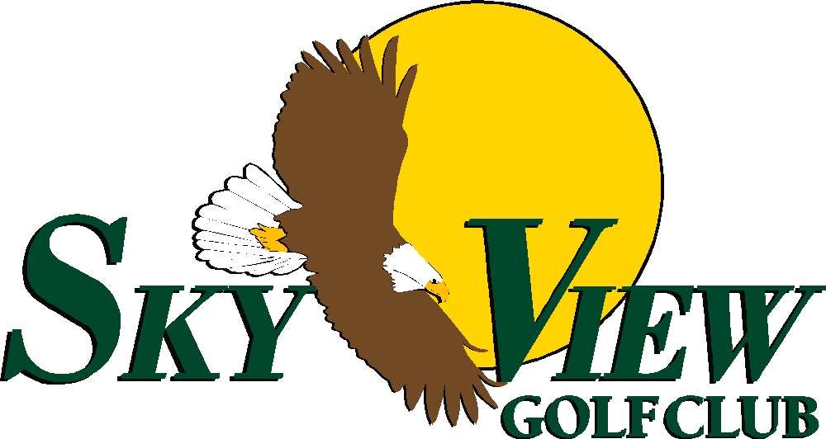
Outing Packages

The Birdie | The Eagle
- Continental Breakfast | - Continental Breakfast
- Lunch ticket to be redeemed at the halfway house during the round. One hamburger or two hot dogs with a soda/water  - Green fees, cart fees  - Prizes ($10.00 pro shop credit per player)  - Scoring service provided | - Lunch ticket to be redeemed at the halfway house during the round. One hamburger or two hot dogs with a soda/water  - Buffet dinner *see attached buffet menu  - One hour House open bar  - Green fees, cart fees  - Use of practice range  - Prizes ($10.00 pro shop credit per player)  - Scoring service provided

The Double Eagle
- Buffet Lunch
- Buffet Dinner
- Open Bar (House) for 1 hour ($2.00 additional per person for an upgrade to premium)
- Green fees, cart fees
- Use of practice range
- Prizes ($10.00 pro shop credit per player)
- Scoring service provided

Add on Domestic Draft Beer Lunch to any package for an additional cost per
(Maximum of 2 hours)

A minimum of 50 people are required for all banquet packages.
Larger groups will be required to eat meals at specific time frames.

Packages include NJ state sales tax. Food and beverage subject to 20% service charge

Lunch Buffet Menu

Salad Bar
Garden Greens
Mix of Baby Kale, Spinach, Romaine, and Swiss Chard
Vegetables
Carrots, Cucumber, Tomatoes
Croutons
Garlic and Herb Roasted
Dressings
Ranch, Toasted Sesame

Off The Grill
Hamburgers
Lettuce, Tomato, Onion, American & Cheddar Cheese Potato Roll
Hot Dogs
All beef hotdogs, sauerkraut, relish, mustard

Sides
Dill Pickles
Homemade Rosemary and Sea Salt Potato Chips
Homemade Coleslaw

Dessert
Ice Cream Sundae Bar
Vanilla & Chocolate Ice Cream
Oreo pieces, M&Ms, Toasted Coconut, Reese’s Pieces, Caramel,
Chocolate Syrup, Rainbow Sprinkles

Add Ons
(additional cost per person)
Grilled/BBQ/Jerk Chicken Breasts
Baby Back Ribs
Shrimp Cocktail
Baked Beans
Jalapeno Corn Bread

Dinner Buffet Menu

Salad Bar
Garden Greens
Mix of Baby Kale, Spinach, Romaine, and Swiss Chard
Vegetables
Carrots, Cucumber, Tomatoes
Croutons
Garlic and Herb Roasted
Dressings
Ranch, Toasted Sesame

Pasta Station
Penne Vodka, Fettuccini Alfredo, and Shells with Marinara Sauce

Choice Of TWO Entrees

Chicken Francaise | Swedish or Italian Meatballs | Roasted Farro Island Salmon
Chicken Marsala | Stir Fry Beef and Broccoli | Tilapia Oreganata
Chicken Florentine | Eggplant Parmesan | Roasted Pork Loin
Chicken Hawaiian | Sausage and Peppers

Roasted Red Bliss Potatoes
Olive Oil, Garlic, Herbs

Roasted Vegetables
Seasonal Selection

Basket of Warm Bread
Butter

Dessert
Ice Cream Sundae Bar
Vanilla & Chocolate Ice Cream
Oreo pieces, M&Ms, Toasted Coconut, Reese’s Pieces, Caramel,
Chocolate Syrup, Rainbow Sprinkles

Add Ons
(additional cost per person)
Carving Station: Glazed Turkey, Top Round of Beef,
or Pastrami Brisket
Baby Back Ribs
Shrimp Cocktail

